1.On your Windows laptop or PC, open 'System Information' and take a screenshot showing your OS version, processor, and RAM details.

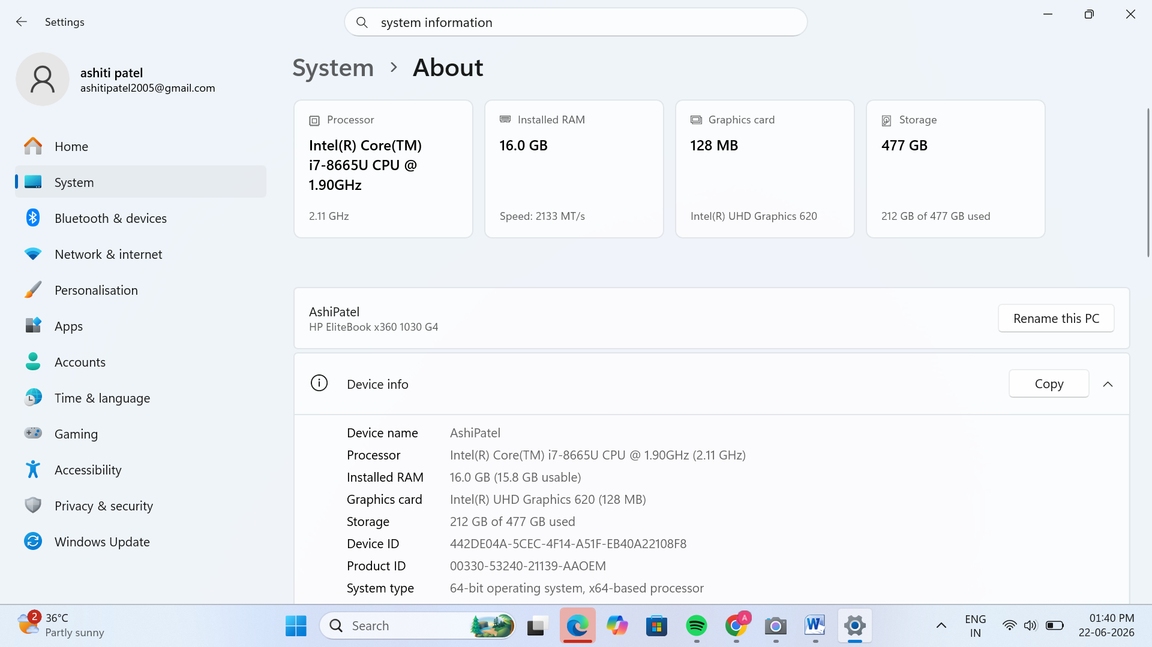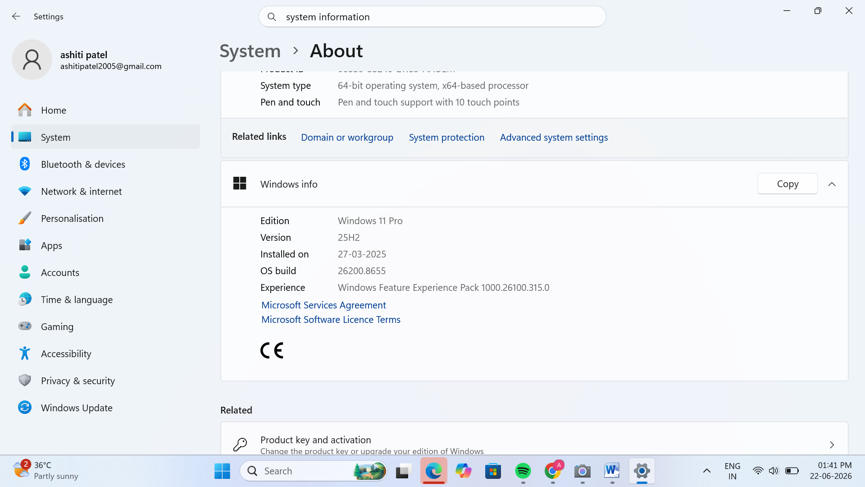

2.Download any official Linux distribution ISO (like Ubuntu or Fedora), and use Rufus or BalenaEtcher to create a bootable USB drive for installation.<br><br><em><strong>Hint:</strong> If you don't have a spare USB, use a virtual machine tool like VirtualBox to mount the ISO and start the installation process virtually.</em>

->Creating a Bootable USB Drive Using a Linux ISO
- First, I downloaded the official Ubuntu ISO file from the Ubuntu website.
- Then, I inserted a USB drive into my computer and opened Rufus.
- In Rufus, I selected the connected USB drive and chose the downloaded Ubuntu ISO file.
- I kept the default settings and clicked on Start to create the bootable USB drive.
- I waited for the process to complete. After a few minutes, Rufus showed that the bootable USB was ready.
- Finally, I safely removed the USB drive. The USB can now be used to install Ubuntu on a computer.
Alternative Method: If I did not have a spare USB drive, I could use VirtualBox to mount the Ubuntu ISO file and start the installation process virtually without making a bootable USB.
3.On a macOS device (or using a macOS virtual machine), open 'System Preferences' and change the desktop wallpaper, then adjust the system language to Hindi or Gujarati.<br><br><em><strong>Hint:</strong> Find 'Language & Region' in System Preferences to add or change languages.</em>

->Changing Wallpaper and Language on macOS
- First, I opened System Preferences on the Mac.
- I clicked on Desktop & Screen Saver and chose a different wallpaper that I liked.
- After changing the wallpaper, I went back to System Preferences and opened Language & Region.
- I clicked the + button and selected Hindi from the list of languages. (Gujarati can also be selected in the same way.)
- Then, I clicked Add and chose Use Hindi as the primary language.
- Finally, I logged out and logged in again so that the language changes could be applied properly.
By following these steps, I was able to change the desktop wallpaper and adjust the system language on macOS.
4.Install a fresh copy of Ubuntu Linux (real or virtual machine) and create a new user account named 'gamer'. After installation, enable automatic login for this user and take a screenshot of the login screen showing the username.

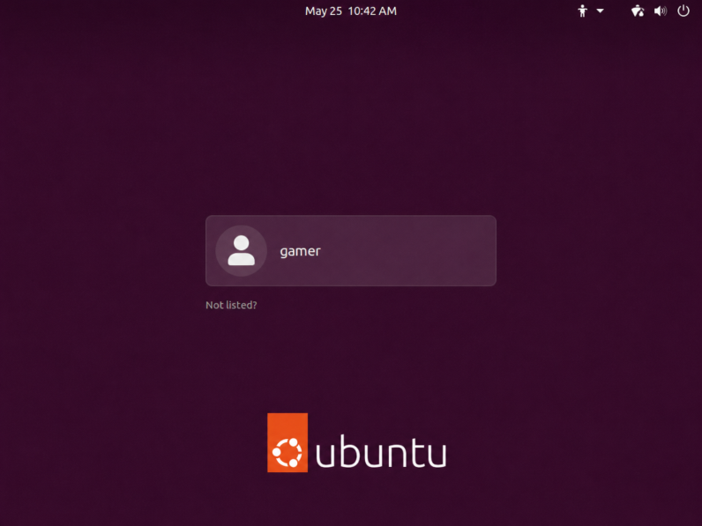

5.Use ChatGPT to generate a step-by-step guide for installing Windows 10 on a laptop, including partitioning tips and post-installation settings for privacy and updates. Follow the guide and note any steps that were unclear or missing.

->Step-by-Step Guide for Installing Windows 10 on a Laptop

Step 1: Download Windows 10
- Open a web browser and visit the official Microsoft website.
- Download the Windows 10 Media Creation Tool.
- Insert an empty USB drive (minimum 8 GB).

Step 2: Create a Bootable USB
- Run the Media Creation Tool.
- Select "Create installation media for another PC".
- Choose language, edition, and architecture (64-bit is recommended).
- Select USB flash drive and wait for the process to complete.

Step 3: Boot from the USB Drive
- Insert the bootable USB into the laptop.
- Restart the laptop.
- Press the boot menu key (F12, F9, Esc, or Del) depending on the laptop brand.
- Select the USB drive and press Enter.

Step 4: Start Windows Installation
- Choose language, time, and keyboard settings.
- Click Install Now.
- Enter the product key or select "I don't have a product key" if you want to activate later.
- Select the Windows edition and click Next.

Step 5: Partitioning the Disk
Partitioning Tips:
- It is recommended to keep at least 100 GB for the C: drive (Windows drive).
- Create separate partitions for personal files and documents.
- If installing on a new disk, select New to create partitions.
- To perform a clean installation, delete old partitions carefully and select Unallocated Space.
Example:
- C: Drive (Windows) – 100 GB or more
- D: Drive (Data) – Remaining space

Step 6: Complete the Installation
- Select the partition where Windows will be installed.
- Click Next.
- Windows will copy files and restart several times.
- Wait until the installation process is completed.

Step 7: Initial Setup
- Choose your region and keyboard layout.
- Connect to Wi-Fi if required.
- Create a user account and set a password.

Step 8: Privacy Settings
After installation, review the privacy settings:
- Turn Off location tracking if not needed.
- Disable unnecessary diagnostic data sharing.
- Turn Off advertising ID for better privacy.
- Review app permissions such as camera and microphone access.

Step 9: Windows Updates and Drivers
- Open settings→ Update & Security → Windows Update.
- Click check for updates.
- Install all available updates.
- Install laptop drivers from the manufacturer's website if required.

Step 10: Install Essential Software
After setup, install important software such as:
- Web Browser (Google Chrome, Firefox)
- Microsoft Office
- Antivirus software
- PDF Reader

